**ASSIGNMENT 2 (MATLAB CODING)**

**PART 1**

>> a=50

a =

50

>> b=30

b =

30

>> c=a+b

c =

80

>> d=cos(a)

d =

0.9650

>> e=a*b

e =

1500

>> sin(30*pi/100)

ans =

0.8090

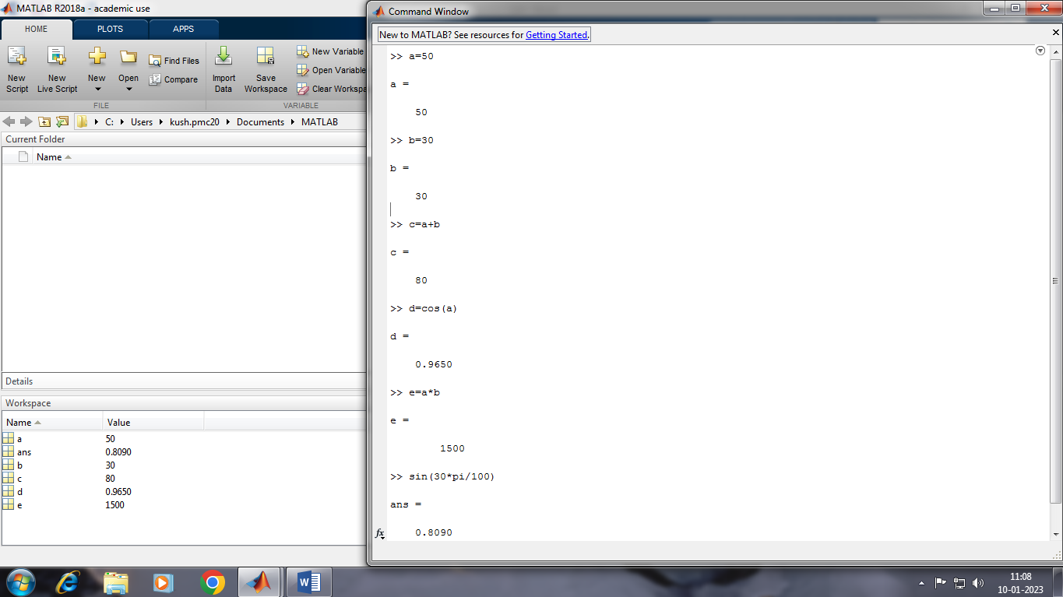

PART 2

x=[1 2 3 4 5 6 7 8 9 10]

x =

1 2 3 4 5 6 7 8 9 10

>> x=[0:5:100]

x =

Columns 1 through 20

0 5 10 15 20 25 30 35 40 45 50 55 60 65 70 75 80 85 90 95

Column 21

100

>> y=x

y =

Columns 1 through 20

0 5 10 15 20 25 30 35 40 45 50 55 60 65 70 75 80 85 90 95

Column 21

100

>> plot(x,y)

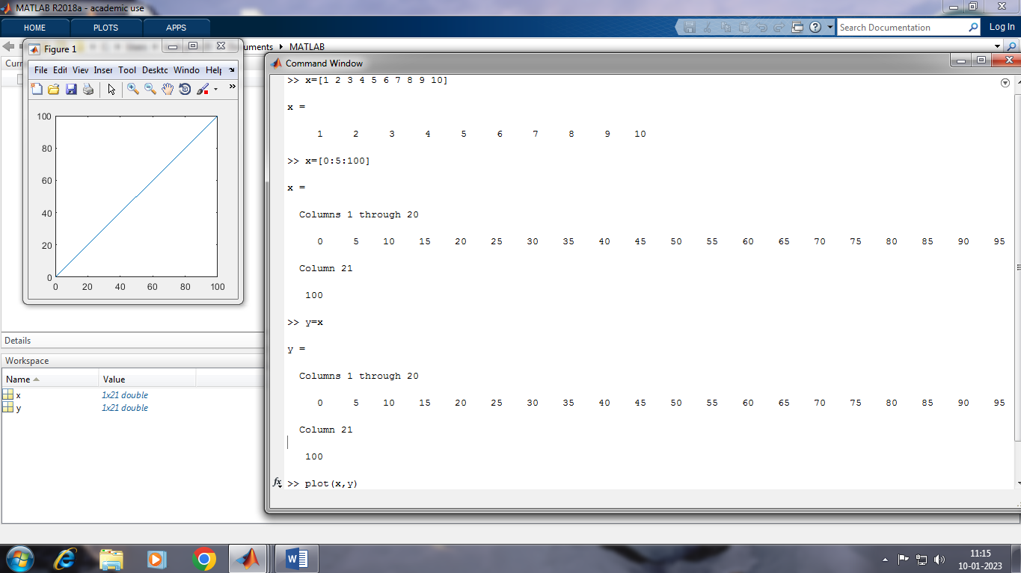

PART 3

>> x=[1 2 3 4 5 6 7 8 9 10]

x =

1 2 3 4 5 6 7 8 9 10

>> x=[-100:5:100]

x =

Columns 1 through 20

-100 -95 -90 -85 -80 -75 -70 -65 -60 -55 -50 -45 -40 -35 -30 -25 -20 -15 -10 -5

Columns 21 through 40

0 5 10 15 20 25 30 35 40 45 50 55 60 65 70 75 80 85 90 95

Column 41

100

>> y=x.^2

y =

Columns 1 through 10

10000 9025 8100 7225 6400 5625 4900 4225 3600 3025

Columns 11 through 20

2500 2025 1600 1225 900 625 400 225 100 25

Columns 21 through 30

0 25 100 225 400 625 900 1225 1600 2025

Columns 31 through 40

2500 3025 3600 4225 4900 5625 6400 7225 8100 9025

Column 41

10000

>> plot(x,y)

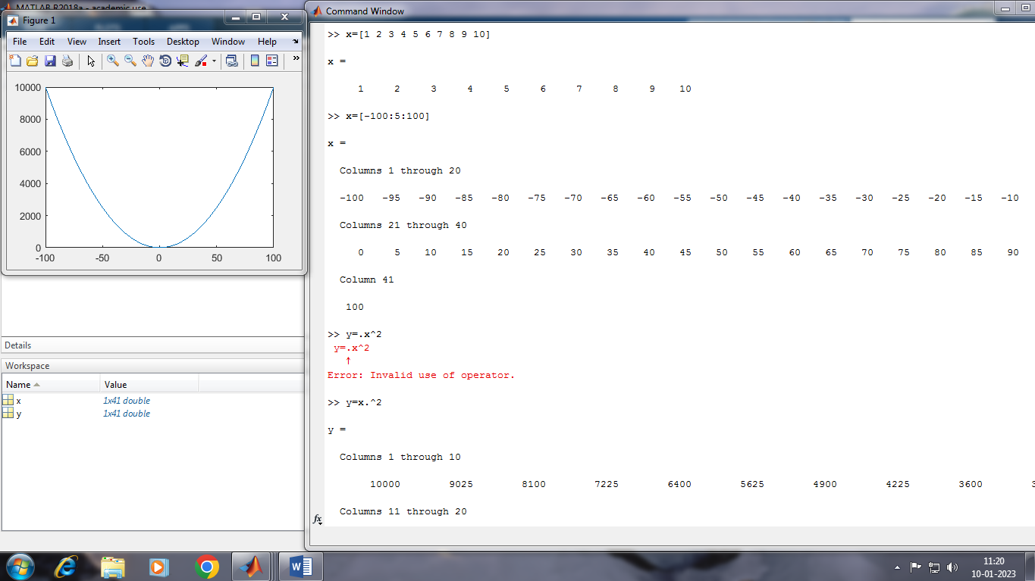

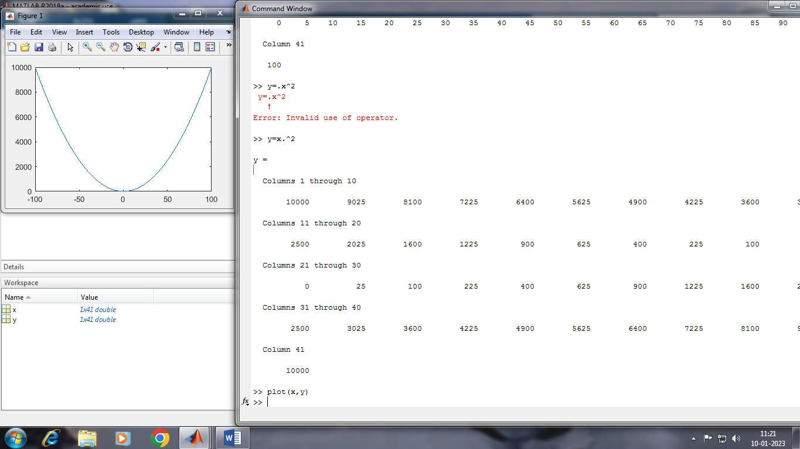

PART 4

>> x=[0:0.01:10];

>> y=sin(x);

>> plot(x,y)

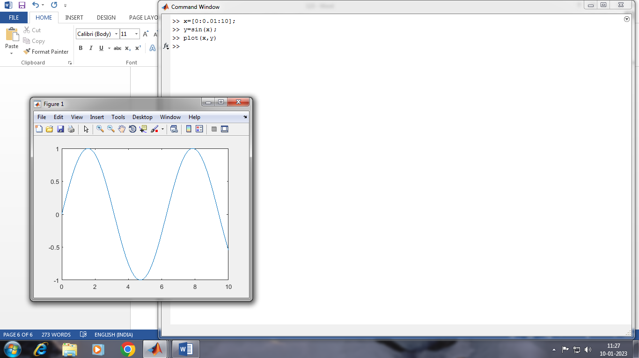

PART 5

>> x=[0:0.01:10];

>> y=sin(x);

>> g=cos(x);

>> plot(x,y,x,g,'.-'),legend('Sin(x)','Cos(x)')

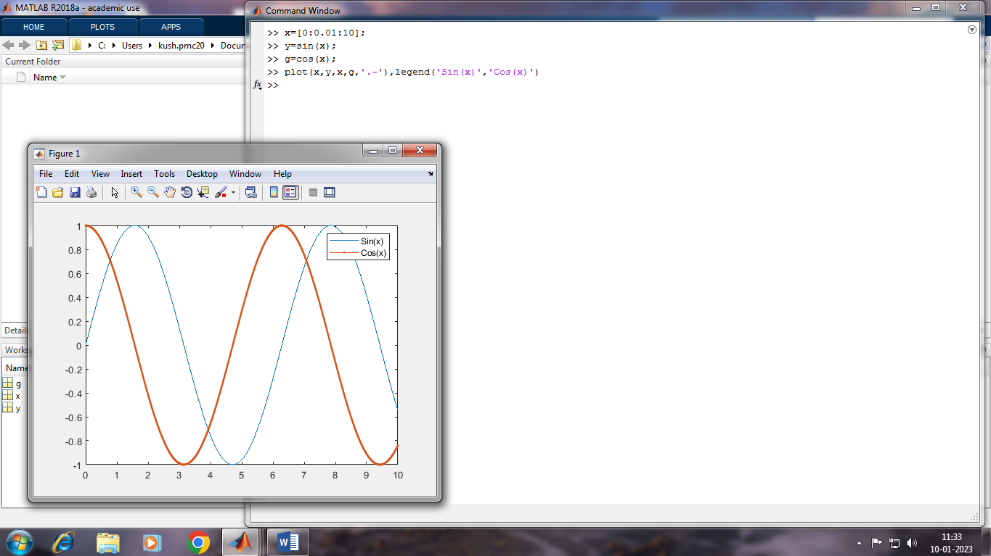

2-D and 3-D PLOTS

PART 6 (LINE PLOTS)

>> x=linspace(0,2*pi);

>> y=sin(x);

>>plot(x,y)

>>hold on

>>y2=cos(x);

>>plot(x,y2,”:”)

>>legend(“sin”,”cos”)

>>hold off

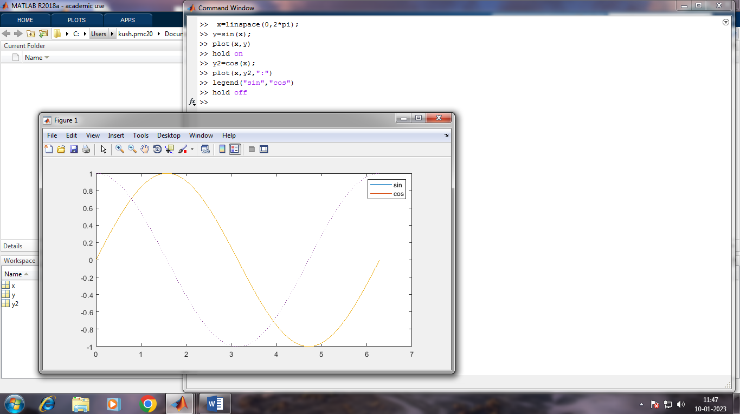

(3-D PLOTS)

>> x=linspace(-2,2,20);

>> y=x';

>> z=x.*exp(-x.^2-y.^2);

>> surf(x,y,z)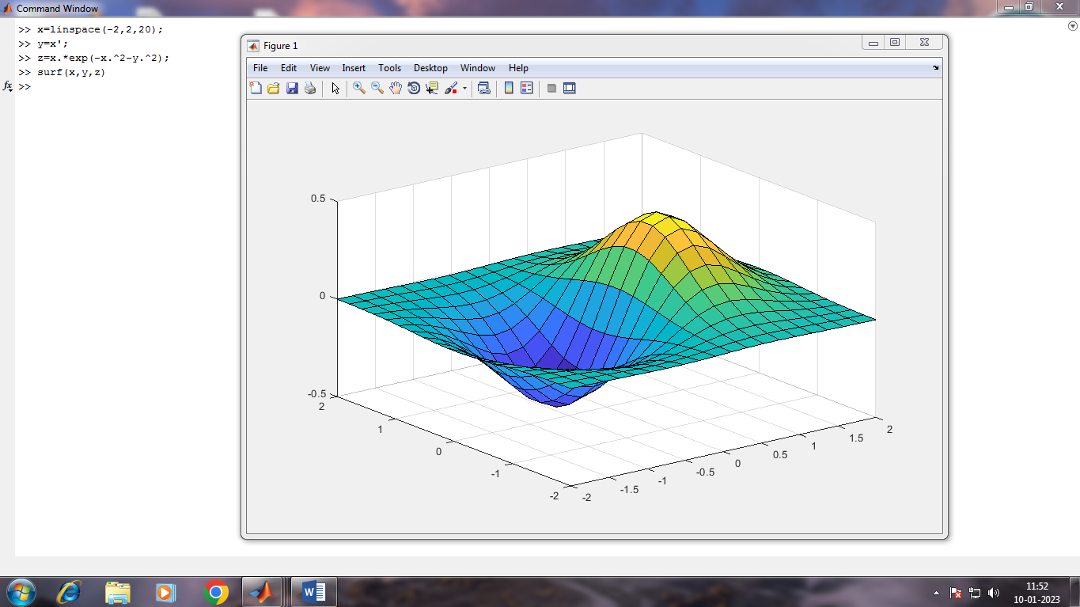

PART 7

FOR LOOP

>> A=zeros(4,4)

A =

0 0 0 0

0 0 0 0

0 0 0 0

0 0 0 0

>> for i=1:4

A(i,i)=1

end

A =

1 0 0 0

0 0 0 0

0 0 0 0

0 0 0 0

A =

1 0 0 0

0 1 0 0

0 0 0 0

0 0 0 0

A =

1 0 0 0

0 1 0 0

0 0 1 0

0 0 0 0

A =

1 0 0 0

0 1 0 0

0 0 1 0

0 0 0 1

